**DevOps Certification Training**

Lab Guide



This section will guide you to:

* Use labs to execute all demos included in this course

This lab has two subsections, namely:

* + 1. Starting practice labs on LMS
    2. Using different IDEs and software required for the DevOps certification training course

**Step 1:** Starting practice labs on LMS

* Login to Simplilearn LMS
* Go to the respective course

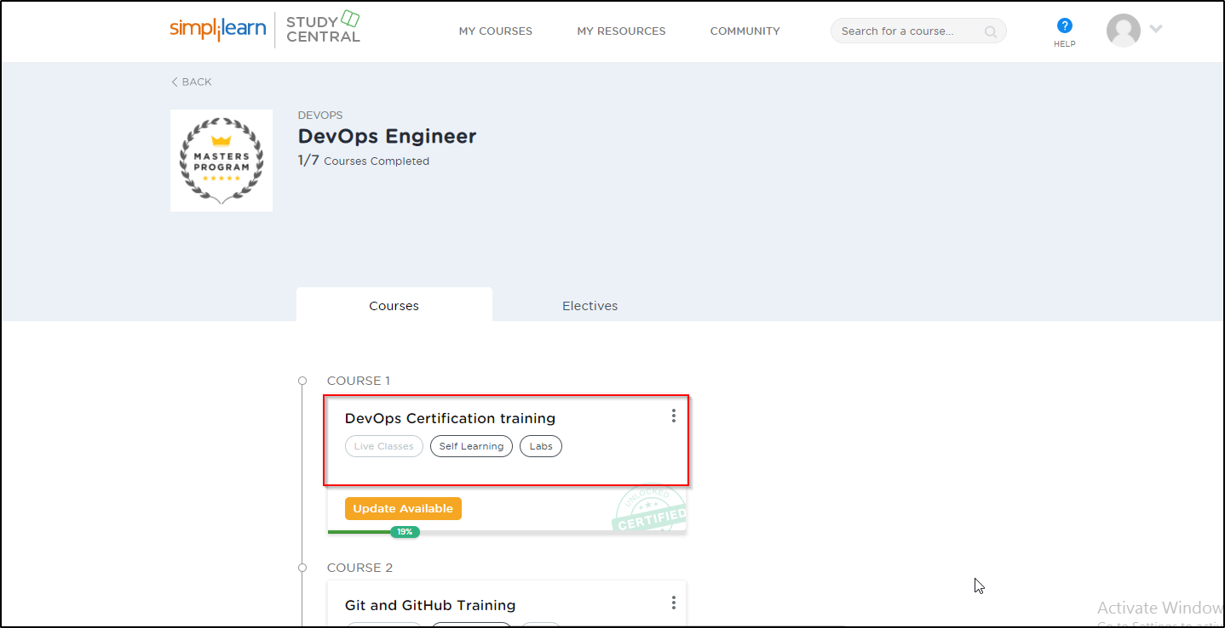

* On the left, you will find the course ToC page
* To its left, you will find the **PRACTICE LABS** tab
* Click on it

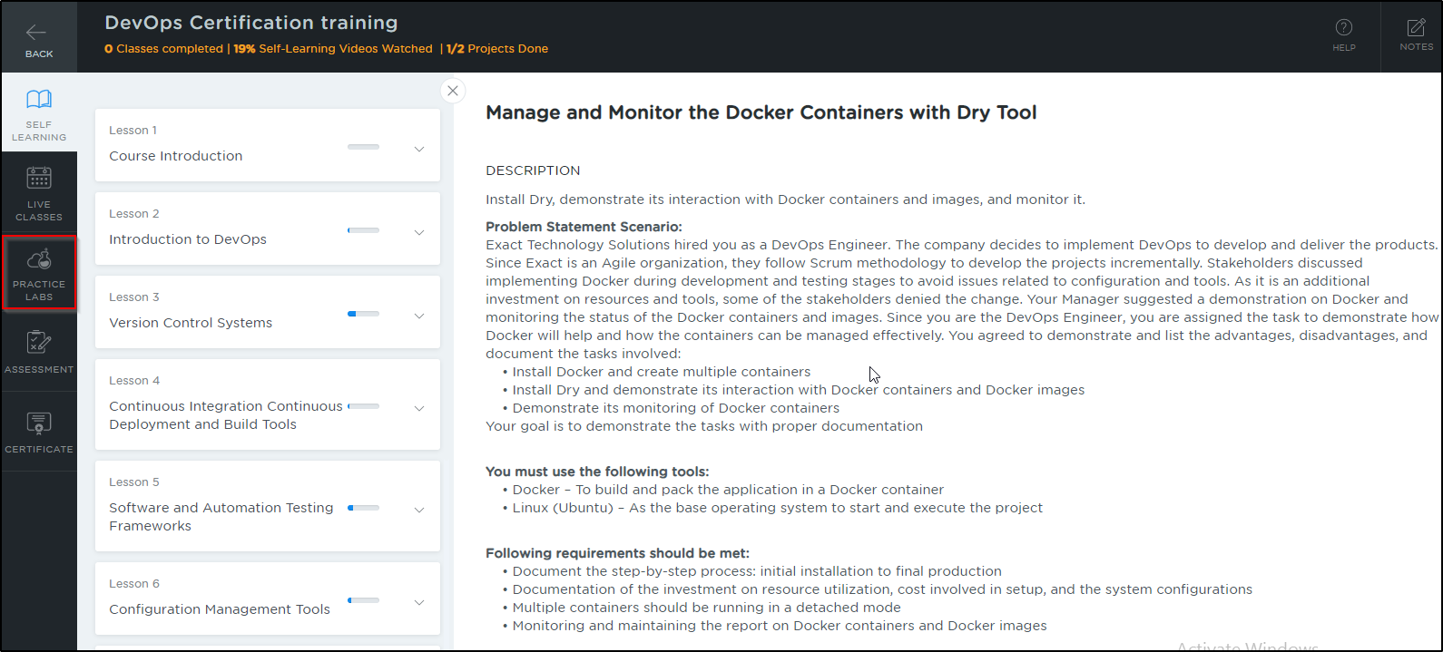

* As a new window opens, read the instructions and click on **LAUNCH LAB**
* This will launch practice labs for this course

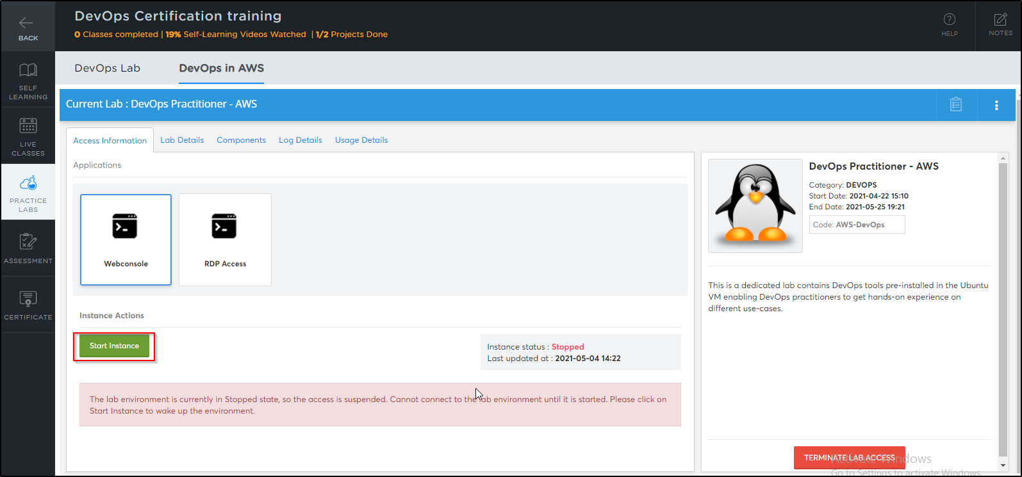

* Once the lab instance is started, click on the *Auth Url* as shown below:

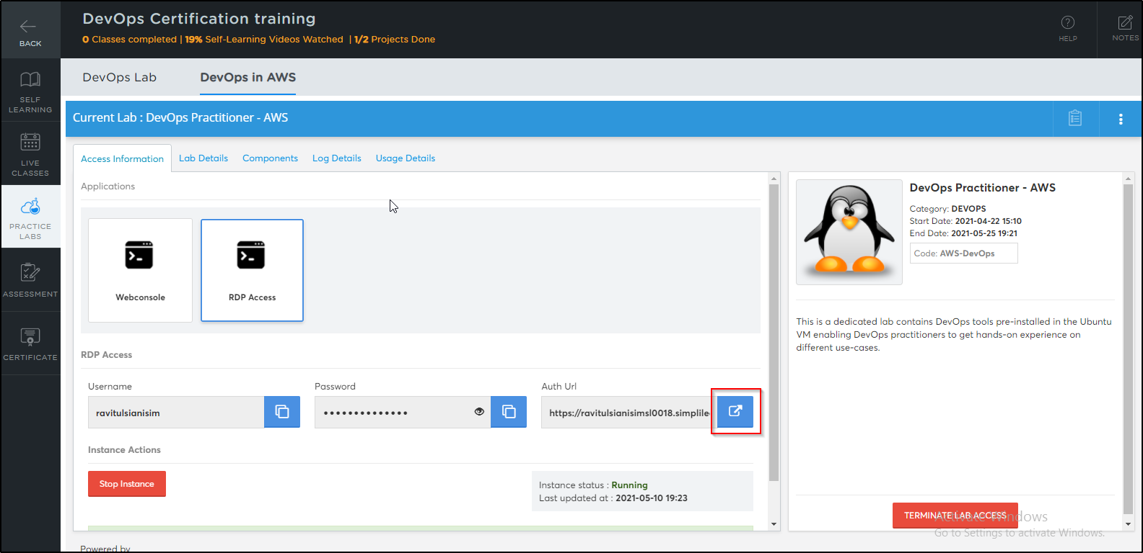

* You will be able to access IDEs and software which are present in labs

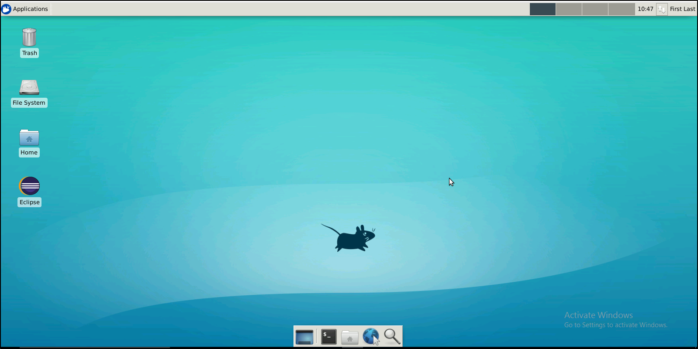

**Step 2:** Accessing the terminal lab through VM.

* Click on the Terminal only lab

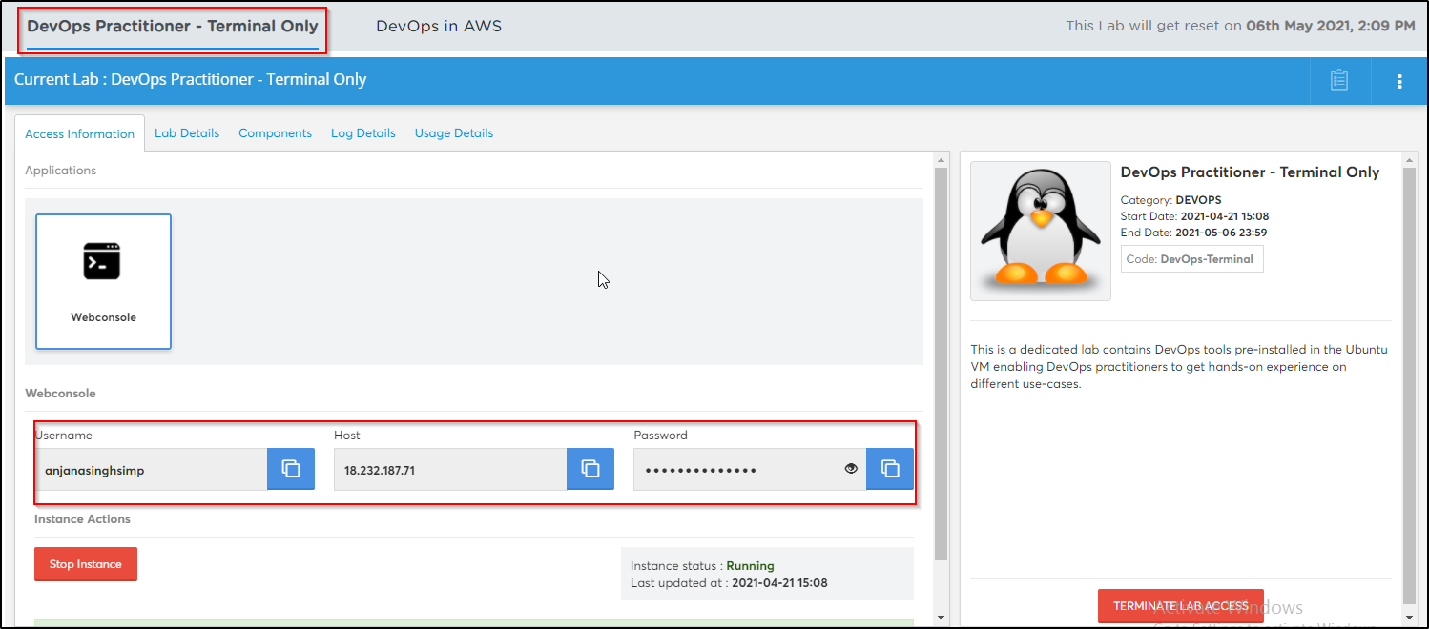

* Please launch the terminal only lab and save the credentials that are shown in the screenshot above
* Open the DevOps in AWS lab

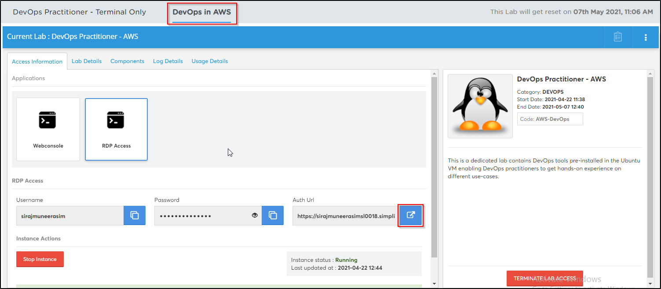

* Once the lab is launched, open the terminal
* Execute the below commands in the terminal in order to establish an ssh connection with the terminal only lab

***ssh username@ip -p 42006***

* Type *yes* and enter the *password* when prompted.



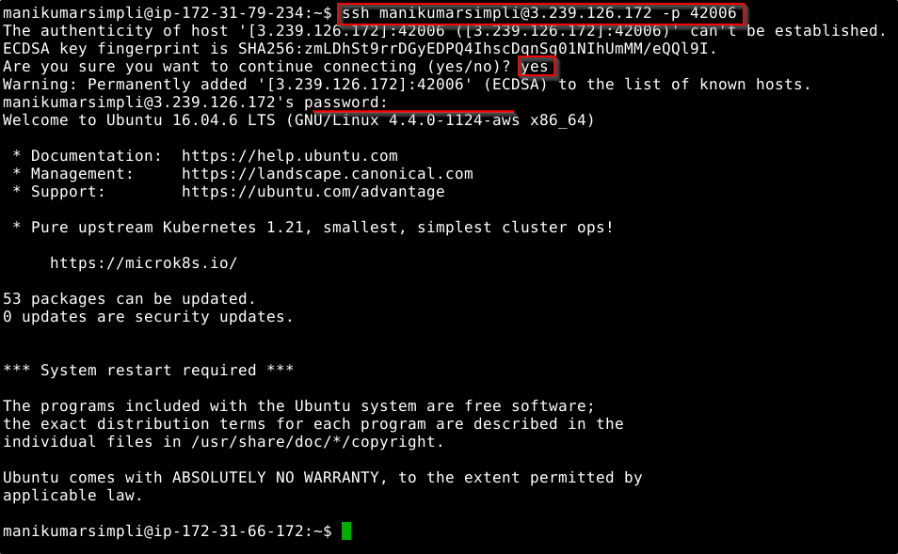

* The terminal only lab has the following tools pre-installed: git, java, maven, nodejs, docker, python, python3.



* In case you want to work on the DevOps AWS lab’s terminal, you will need to open a new terminal without closing the previous one

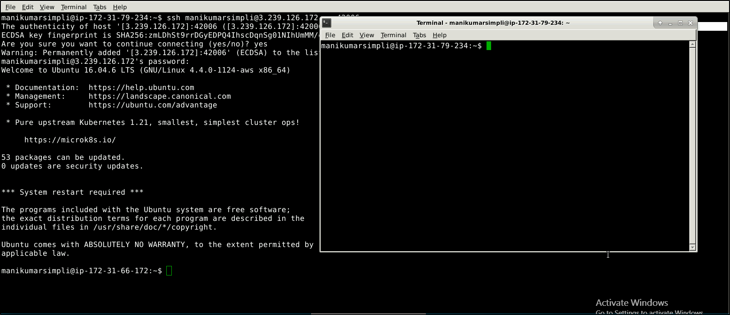

**Step 3:** Using different IDEs and software required

**Linux OS:**

* The virtual machines that we use in the labs are Linux OS
* To verify the version of the linux installation execute the below command in the terminal:

***lsb_release -a***

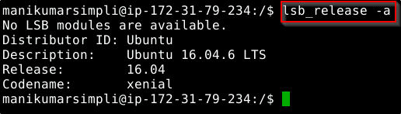

**Java:**

* Java 1.8 is already installed in the labs
* Open the terminal and type **java** **-version** to find whether Java is installed or not

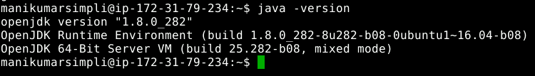

* If Java is not installed in your system, then use the following commands to install the same:

*sudo apt-get install openjdk-8-jdk*

*sudo apt-get install openjdk-8-jre*

**Git:**

* Git is already installed in the labs
* To check whether Git is installed properly or not run the following command:

***git --version***

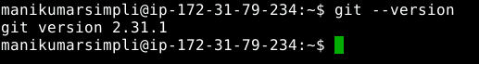

* If git is not installed in your system, then use the following commands to install the same:

*sudo apt-get update*

*sudo apt install git-all*

**Maven:**

* Maven is already installed in your practice labs
* You can use the following command to verify the installation:

***mvn -v***

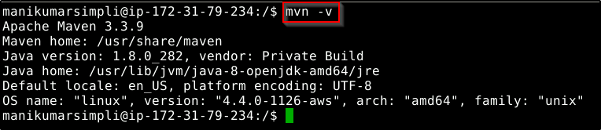

* In case Maven is not installed in your system, you can install it using the commands:

*sudo apt-get update*

*sudo apt-get install maven*

**Eclipse:**

* Double-click on the Eclipse icon
* Select a directory where you want to save your programs
* Select the **Use this as the default and do not ask again** checkbox and click on **Launch**

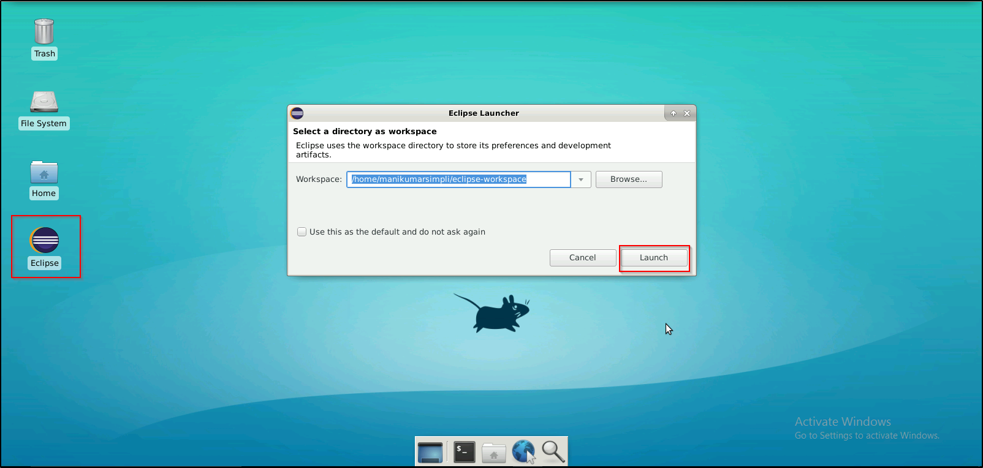

**Jenkins:**

* Jenkins (version 2.287) is already installed in your practice lab
* You will find it in the directory */usr/share*
* Use the following commands to navigate to the above-mentioned directory

***cd /usr/share***

***ls***

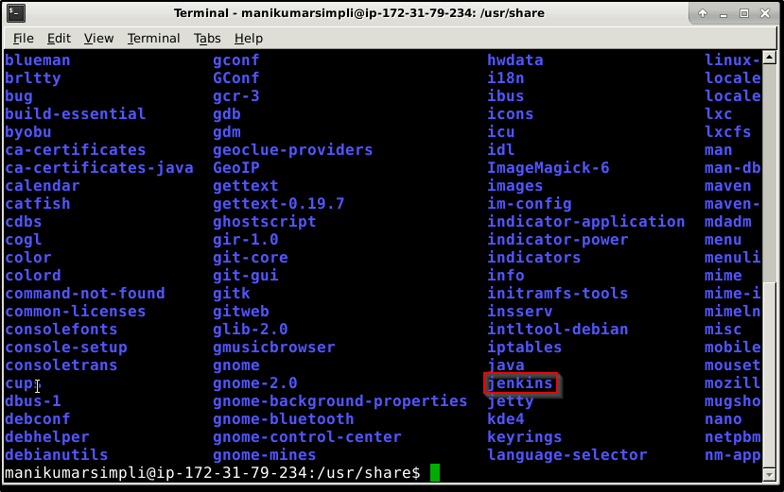

* To login to Jenkins dashboard navigate to ***localhost:8080*** from the browser in the lab
* In case Jenkins is not installed in your practice lab, you can install it using the commands:

*sudo apt update*

*sudo apt install jenkins*

**Node JS:**

* Node JS 14.16.0 version is installed in your practice labs
* To verify the installation, open the terminal and execute the command:

***node -v***

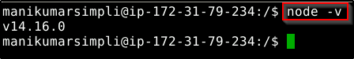

* The command mentioned above displays the Node JS version installed in your practice lab
* If Node JS is not installed in your practice lab, you can install it by using the commands:

*sudo apt-get update*

*sudo apt-get install nodejs*

**Docker:**

* Docker version 18.09.7 is already installed in your practice lab
* To verify the installation, open the terminal and execute the following:

***docker --version***

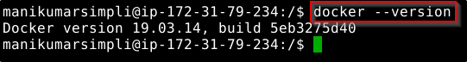

* In case Docker is not installed in your practice lab, you can install it following these steps:

1. Set up the Docker repository using the following commands:

*sudo apt-get update*

*sudo apt-get install apt-transport-https ca-certificates curl software-properties-common*

*curl -fsSL https://download.docker.com/linux/ubuntu/gpg | sudo apt-key add -*

*sudo add-apt-repository "deb [arch=amd64] https://download.docker.com/linux/ubuntu $(lsb_release -cs) stable"*

1. Install Docker using the command:

*sudo apt-get install docker-ce*

**Ansible:**

* Ansible 2.9.19 is already installed in your practice lab
* To verify the installation:

1. Open the command-line interface
2. Type the command:

***ansible --version***

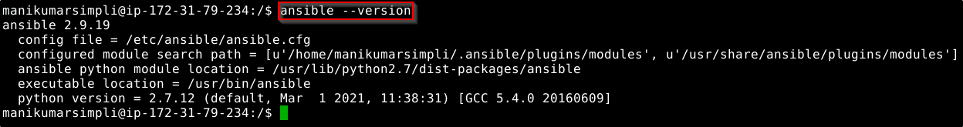

* If ansible is not installed in your practice lab, you can install it by using the commands:

*sudo apt-get install -f*

*sudo apt-get install software-properties-common*

*sudo apt-add-repository ppa:ansible/ansible*

*sudo apt-get update*

*sudo apt-get install ansible*

**Python:**

* Python is already installed in your practice lab
* To verify the installation, open the command-line interface and type the command:

***python --version***

***python3 --version***

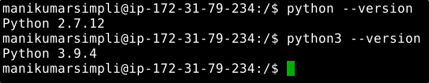

* If python is not installed in your practice lab, you can install it by using the commands:

*sudo apt-get update*

*sudo apt-get install python*

*sudo apt-get update*

*sudo apt-get install python3*